

***Department of computer Science and Engineering***

Assignment-2

# Course code: CSE404

# Course tittle: Artificial intelligence lab

# Submitted by:

Name: Rumman Ahmed Prodhan

ID: 18101018

Section: A1

Semester: Spring

Year: 2021

# Submitted to:

Molla Rashied Hussein

Assistant Professor

University of Asia Pacific

# Problem Statement:

# Create own map from home district to University of Asia Pacific and write in any programming language to implement the A* search to reach the destination from the starting point by using the path costs and straight line distances.

# Tools & Language:

Hand drawn, Python, Google Colab, Google Map, Google Earth

# Diagram:

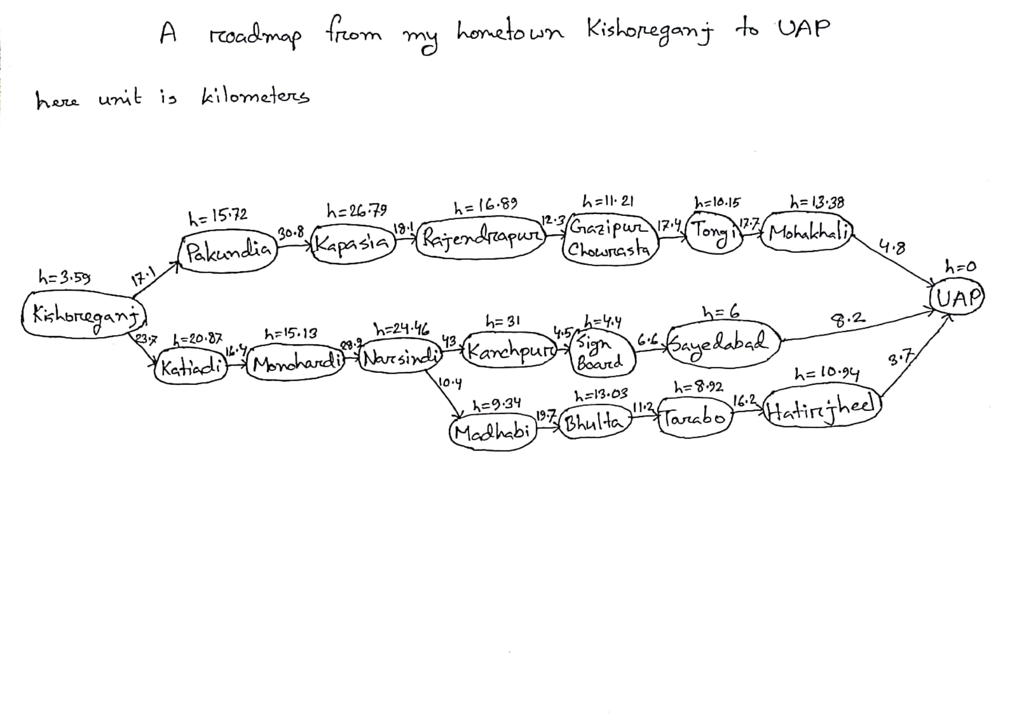

## Map Screenshots:

My home district is Kishoreganj. Firstly, I used Google map to find path between Kishoreganj to UAP. The screenshot is given below:

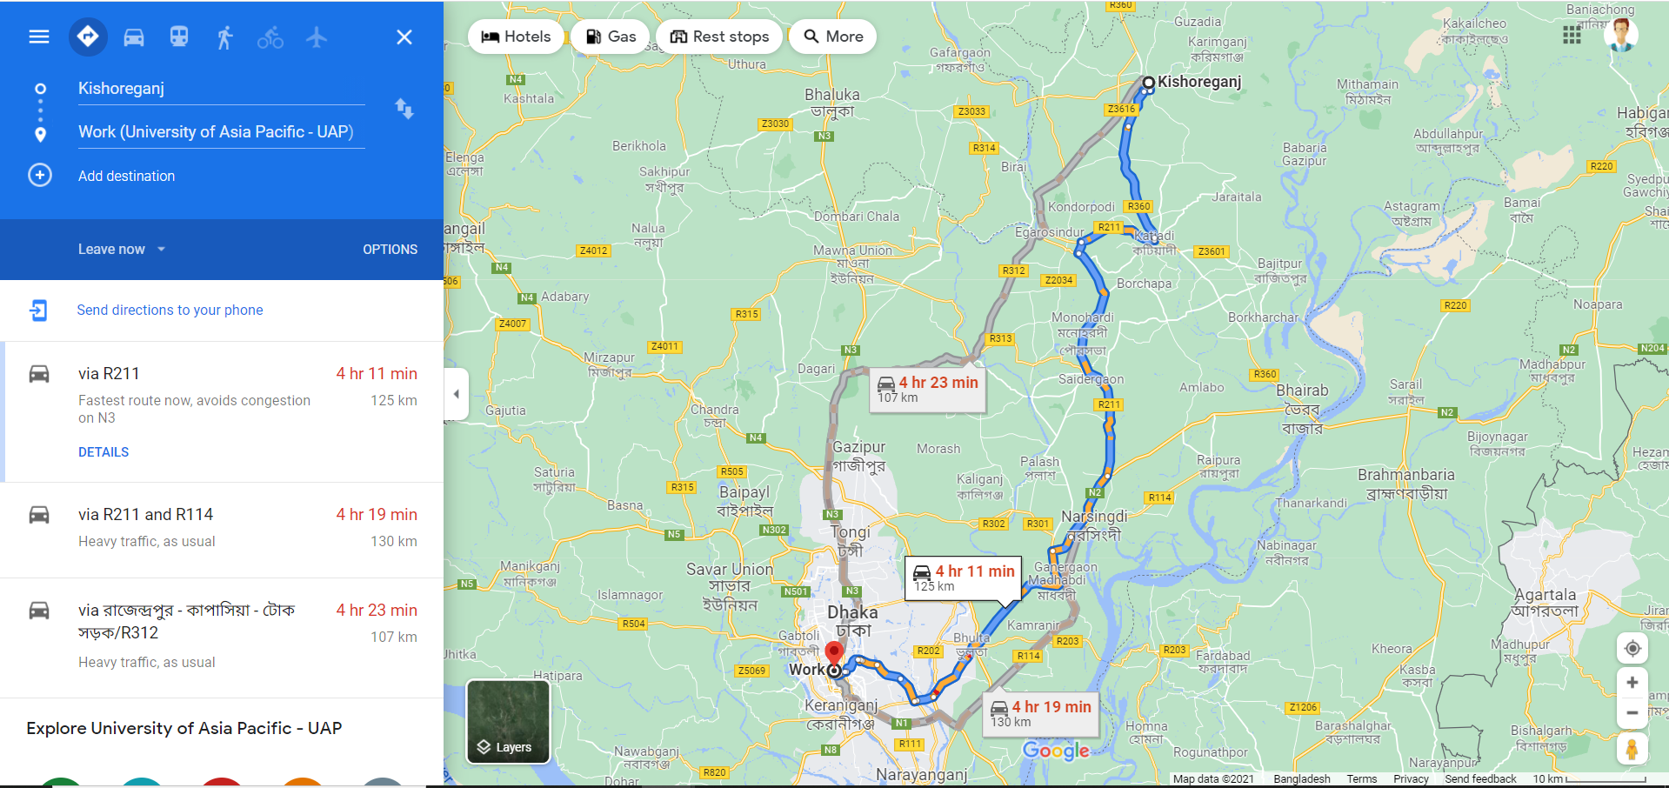

Here we can see three paths in the google map. I broke down every path into short segmented states and calculated their path cost using google map. In the following screen shot my method of calculating path cost is shown. Here is how I calculated the path cost of Kishoreganj to Pakundia which is 17.1 km and I followed the same method for the rest of the states:

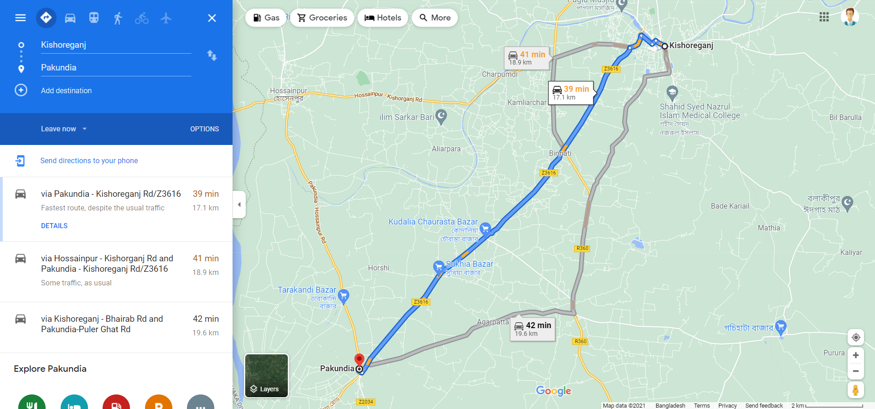

I also calculated every state’s heuristic value by calculating their straight line distances using google earth. The following screenshot contains my method of calculation heuristic value:

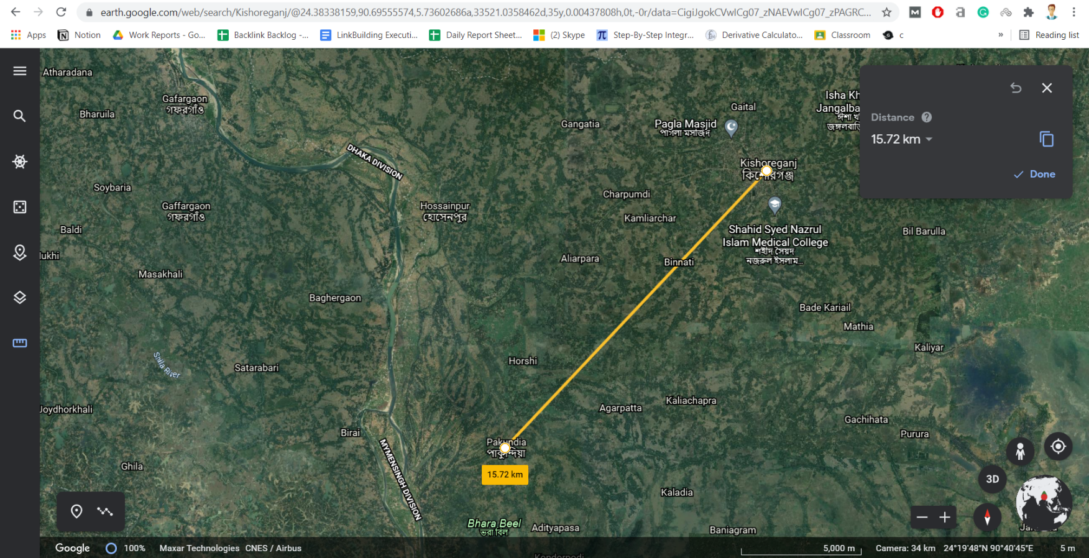

Then I drew the roadmap from Kishoreganj to UAP which was given earlier.

## Calculation:

I also calculated the optimal path and optimal path cost using a* search algorithm.

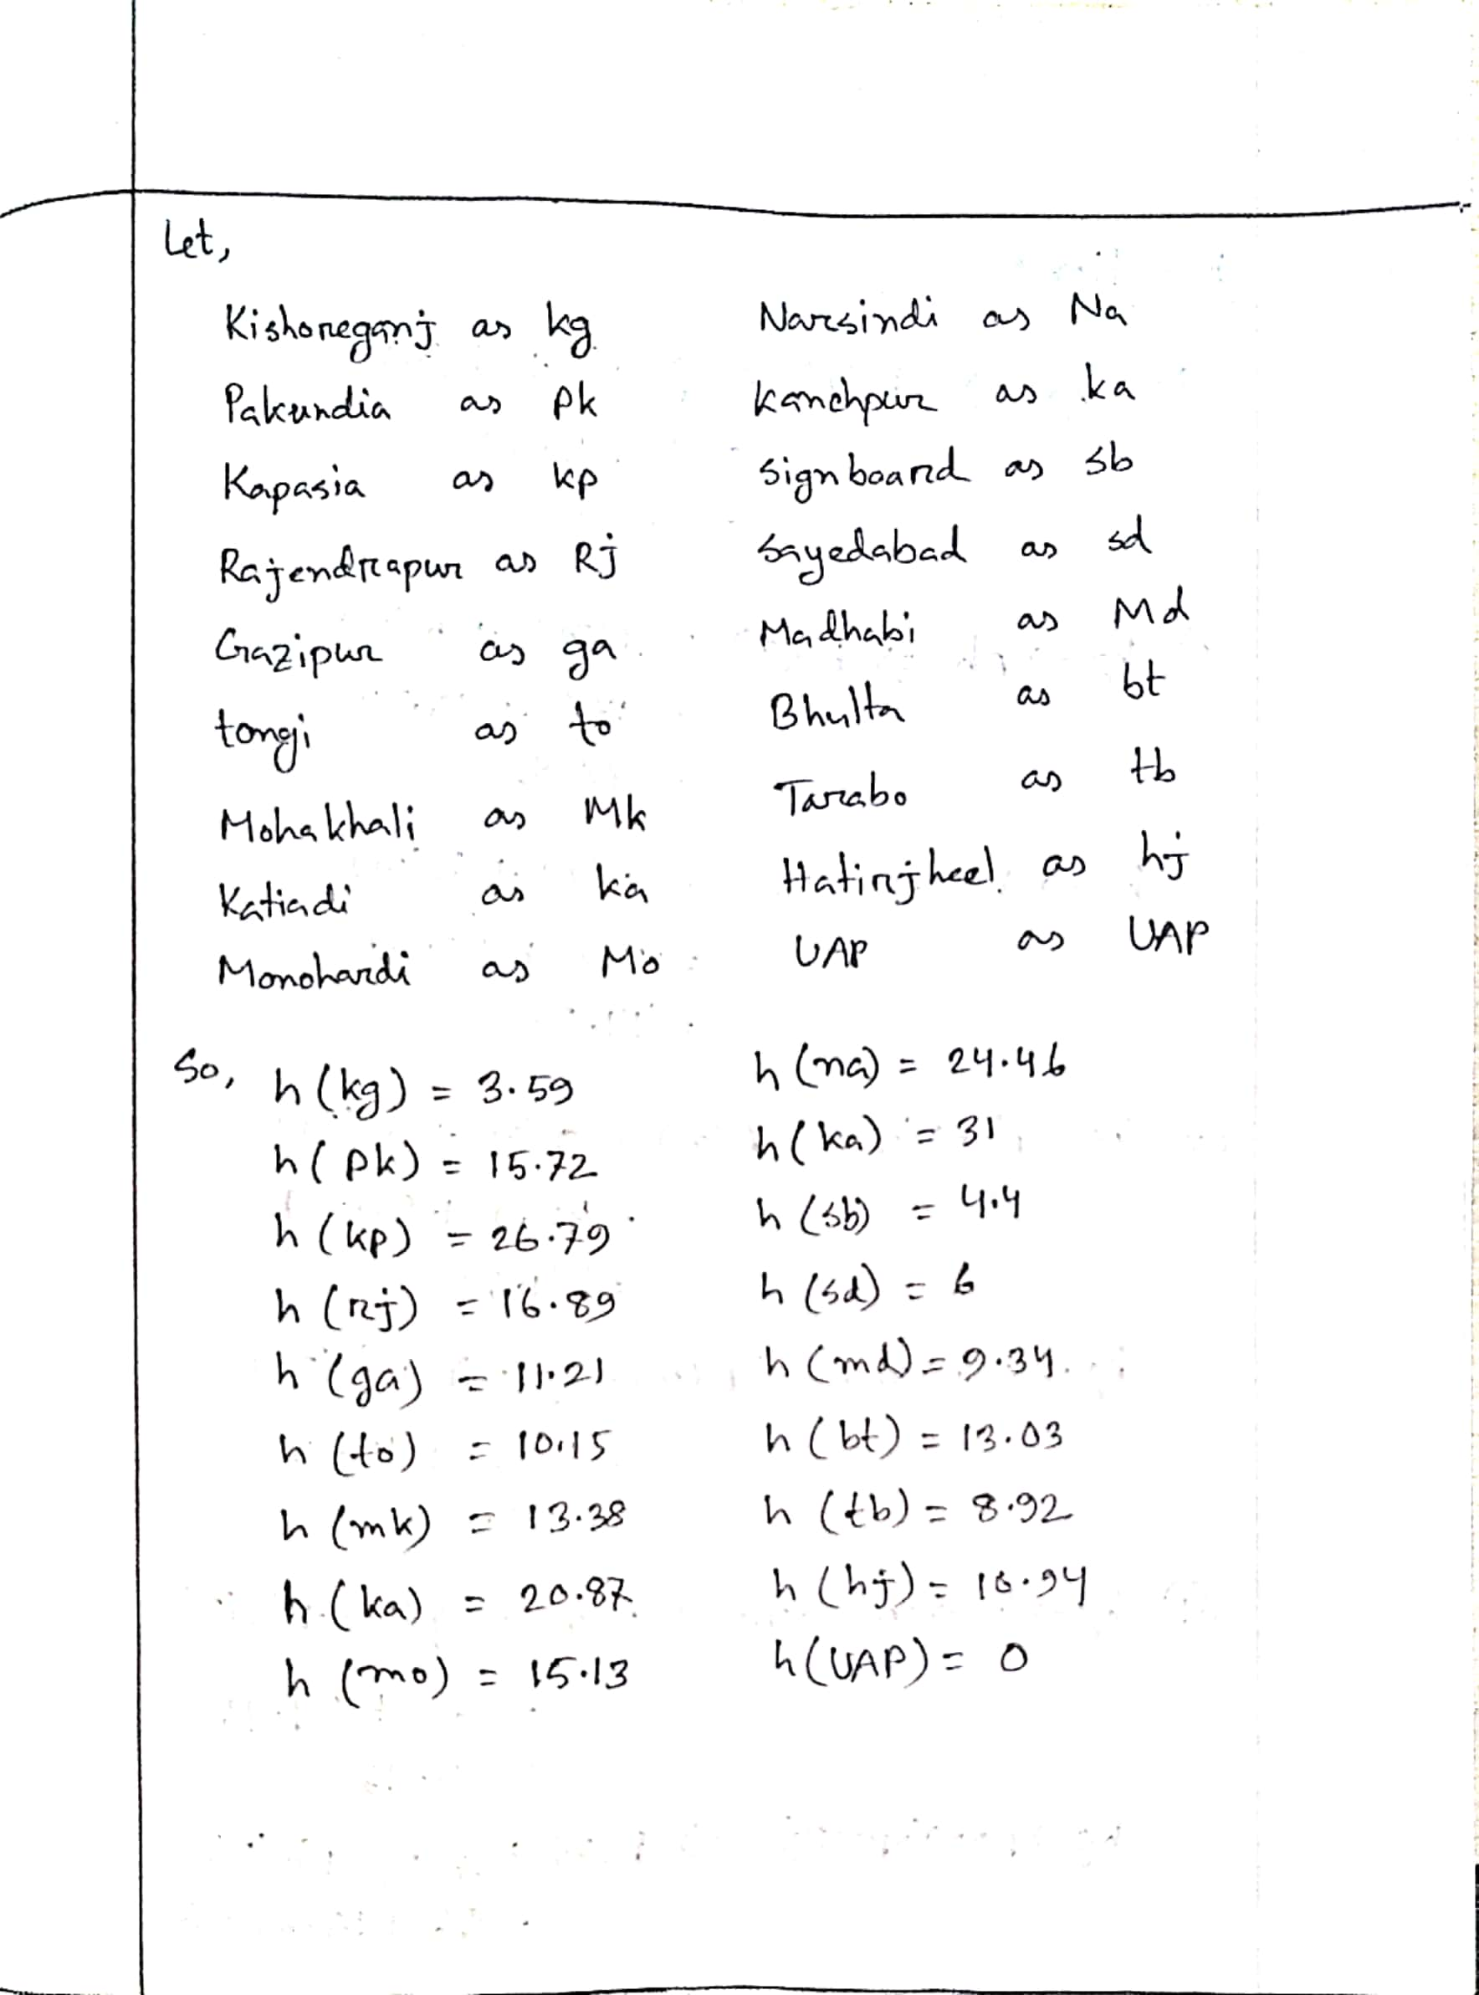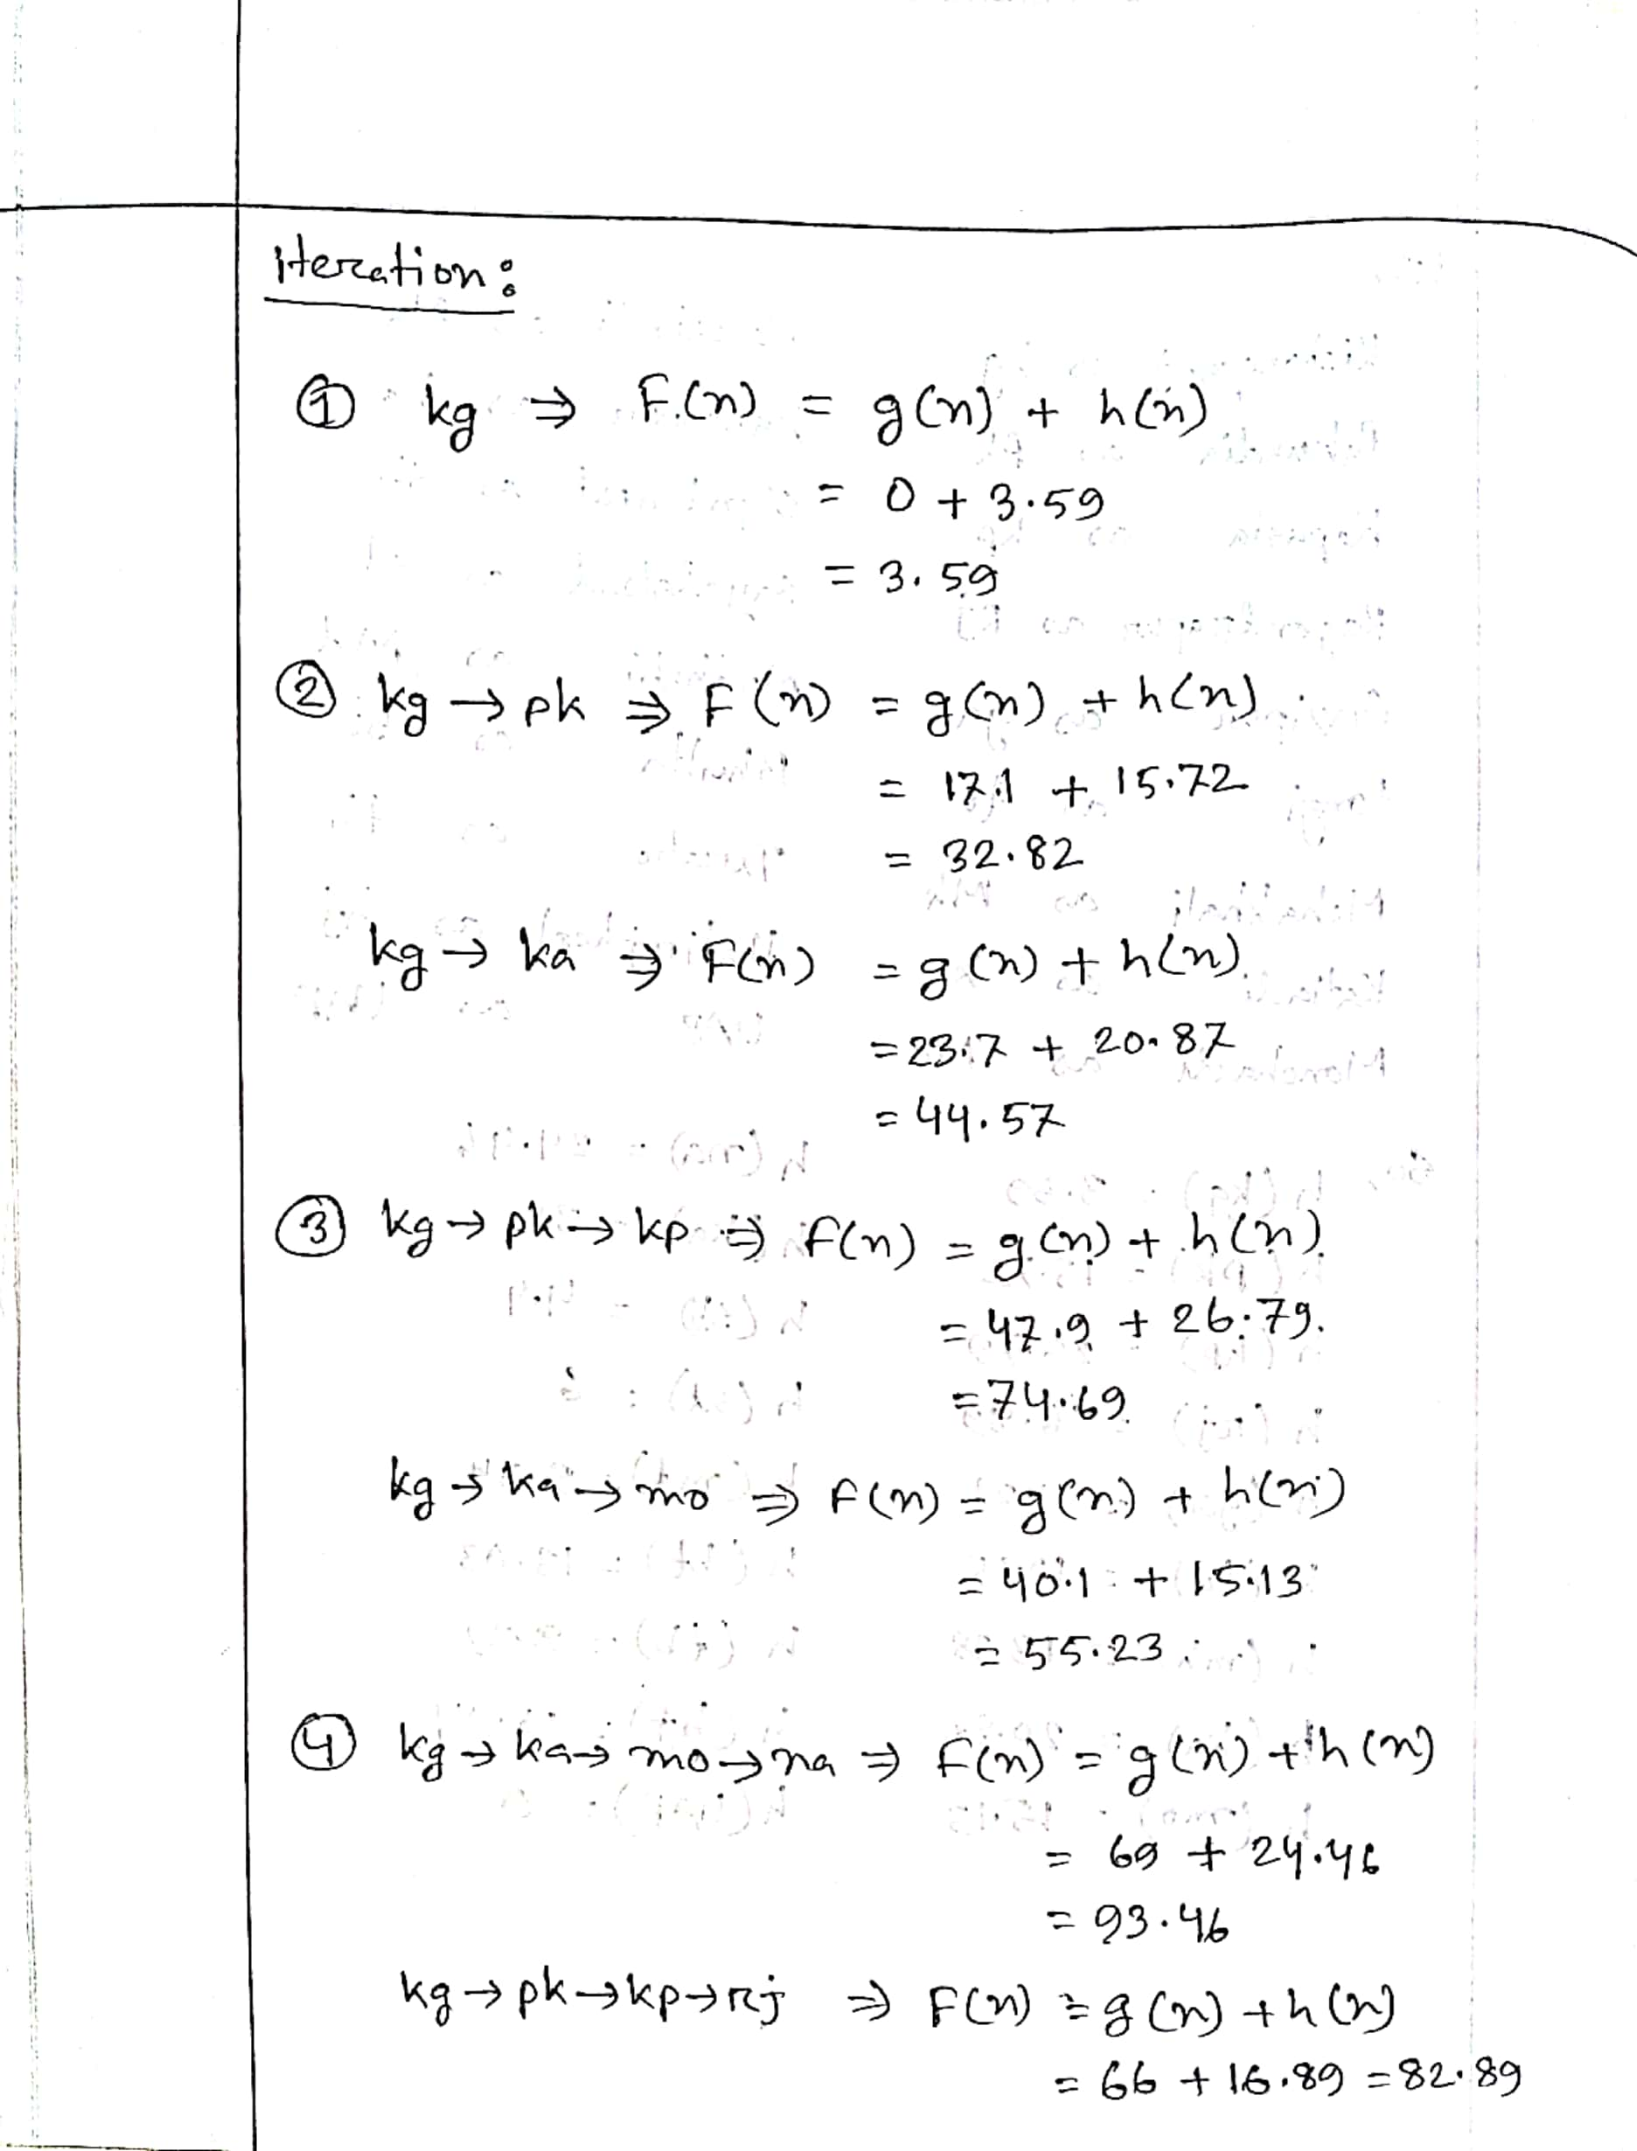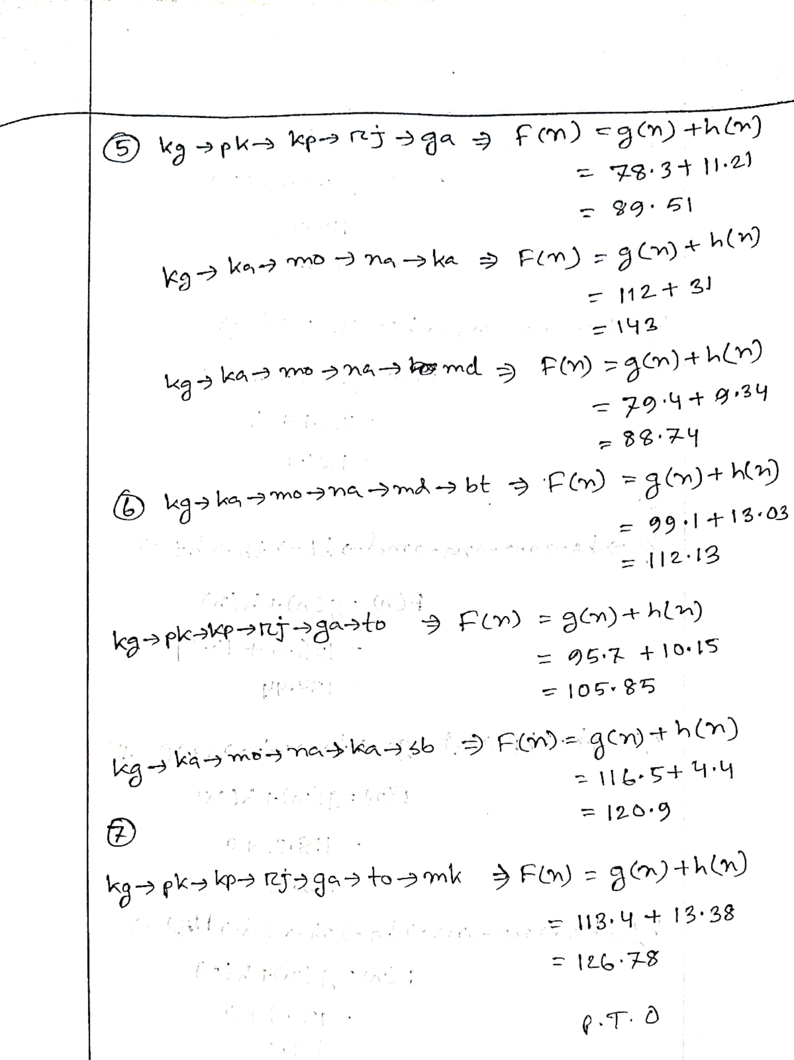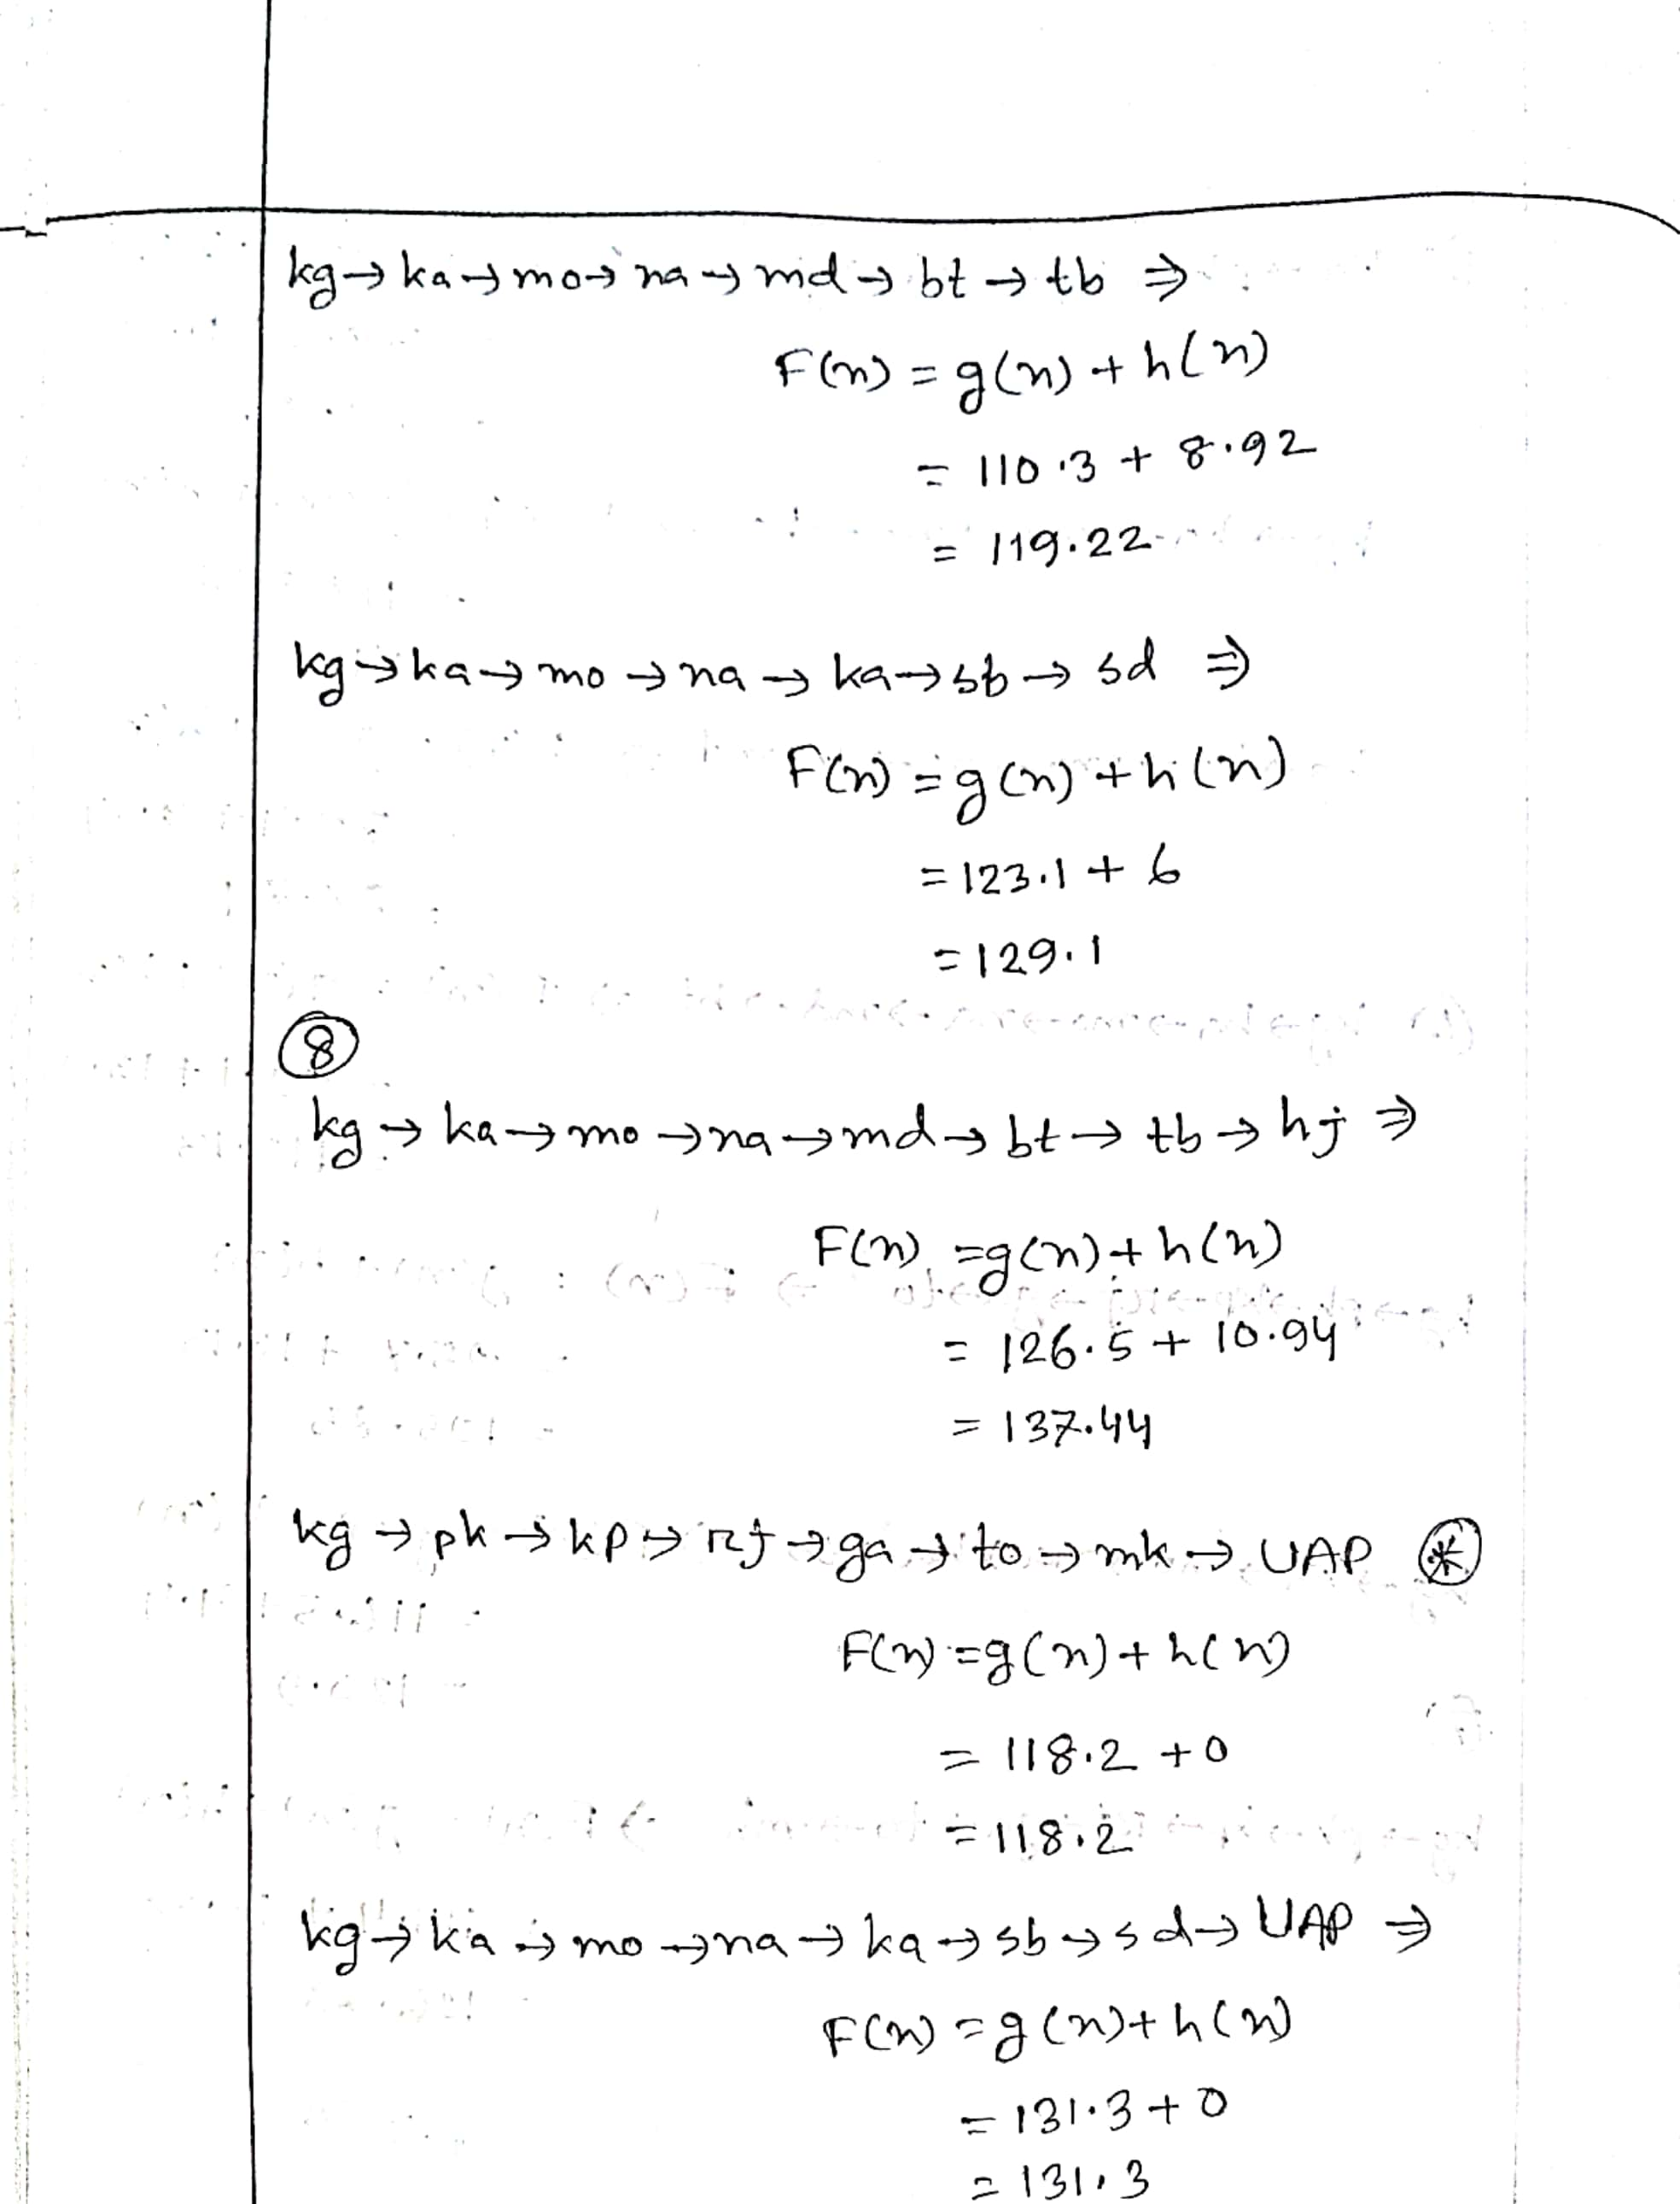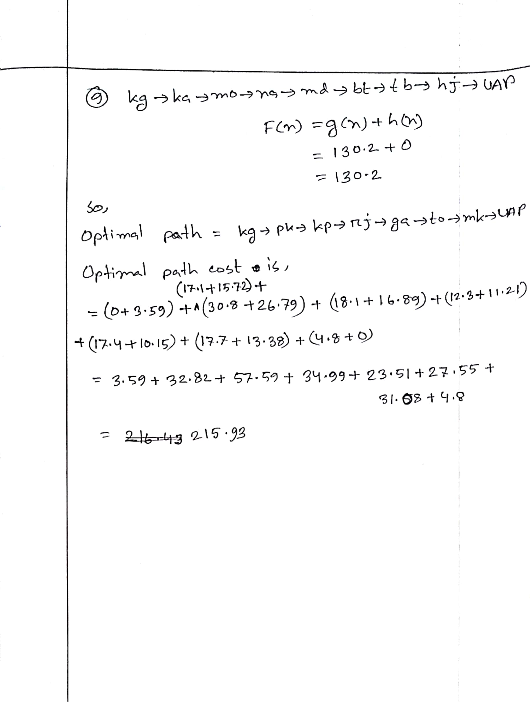

## Code:

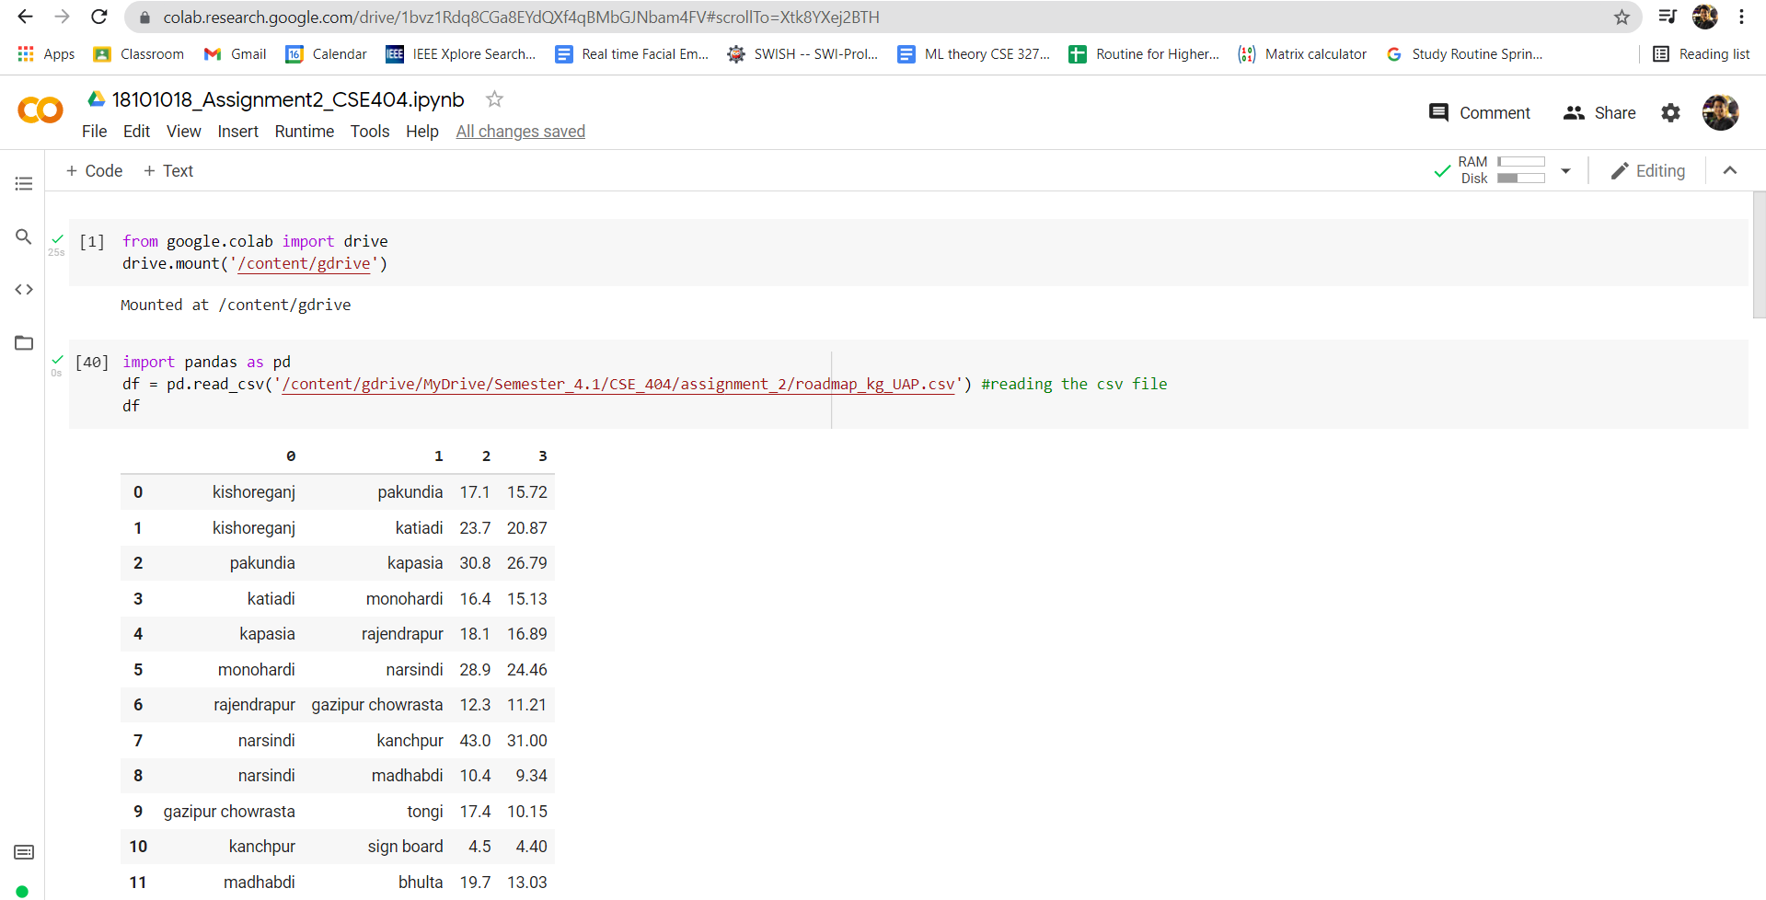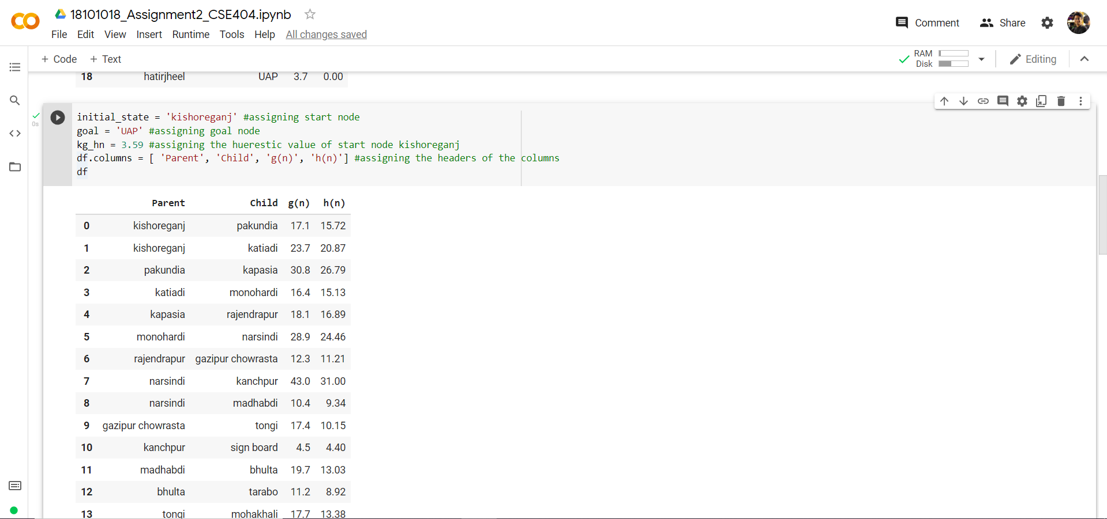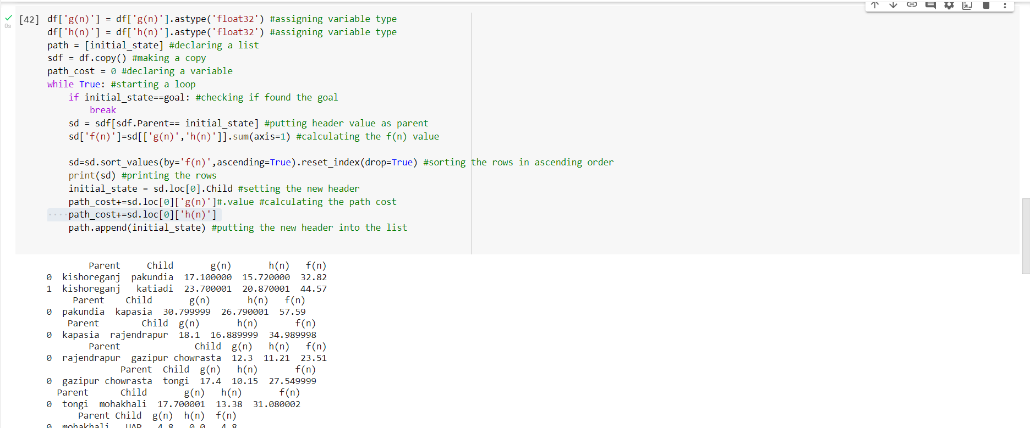

# Result:



# Conclusion:

I created own map from home district Kishoreganj to University of Asia Pacific and write in python programming language to implement the A* search to reach the destination from the starting point by using the path costs and straight line distances. We can see that my result of code and hand calculated result is exactly the same.